**Already Registered Email Address can’t be used by any other user.**

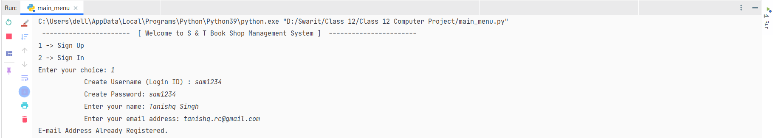

**Email Validation (can’t insert invalid email(s))**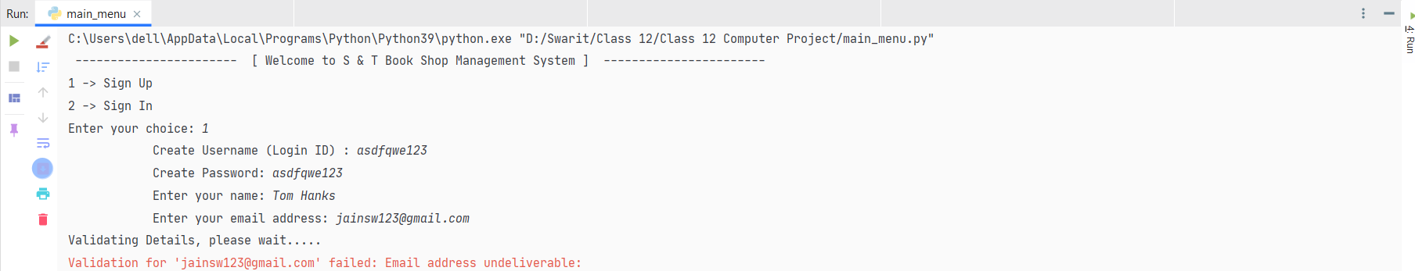

**Admin account can’t be deleted.**

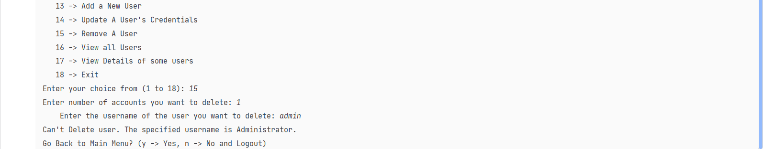

**Can’t login by invalid credentials**

